[Shareholder name]  [Address] | 10 January 2020

RE: PGS Corporate Governance and Corporate Responsibility

Dear Shareholder,
PGS ASA (the “PGS” or the “Company”) continuously strives to improve its efforts in the areas of Corporate Governance and Corporate Responsibility.
The PGS Board of Directors and the Nomination Committee will this year continue the process of actively pursuing a close dialog with our shareholders and investors on the topics of Corporate Governance and Corporate Responsibility.
We therefore invite you to a meeting or a conference call to discuss any element of Corporate Governance or Corporate Responsibility, including the agenda and proxy card for our 2020 AGM, the content of our responsibility review, our corporate governance structure and our principles for executive compensation. This is an opportunity for you to ask questions and/or provide your comments related to the Company’s governance matters.
To represent the Board of Directors and the Nomination Committee in these meetings we have elected Lars Ragnar van der Bijl Mysen, the Company’s General Counsel, Secretary to the Board of Directors and Secretary to the Nomination Committee. He will be able to answer any question relating to our work in these areas, and he is instructed to bring feedback to the Board of Directors and the Nomination Committee following these meetings. The Board of Directors and the Nomination Committee will consider any investor feedback, but no assurances are given that comments will result in a change of policy or otherwise.
We encourage you to contact Mr. Mysen by January 31, 2020 if you would like to set up a meeting or a conference call on these topics. His contact details are as follows:

Email: lars.mysen@pgs.com

Address: PGS ASA
P.O.Box 251, Lilleaker
0216 Oslo, Norway

Phone: +47 67 51 43 65
+47 900 77 595

We hope and trust that this initiative will give our shareholders further insight into and comfort with our serious efforts and work within these areas.
PGS ASA
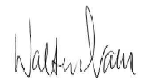 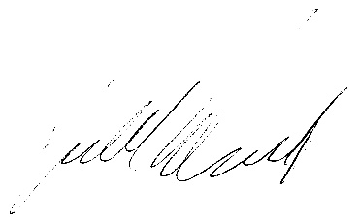 Walter Qvam Harald Norvik
Chairperson of the Board of Directors Chairperson of the Nomination Committee

